# Project Design Phase 1

Solution Architecture

|  |  |
| --- | --- |
| Date | 17 October 2022 |
| Team lD | PNT2022TMID45278 |
| Project name | Project-Real Time River Water Quality  Monitoring And Control System |
| Maximum Marks | 2 marks |
|  |  |

# Solution Architecture:

Solution architecture is a complex process - with many sub-processes -

# that bridges

the gap between business problems and technology solutions. Its goals are to:

* Find the best tech solution to solve existing business problems.
* Describe the structure, characteristics, behavior, and other aspects of

The software to project stakeholders.

* Define features, development phases, and solution requirements.

# Provide specifications according to which the solution is defined, managed,and delivered.

Solution Architecture Diagram:

Fast SMS

Mobile phone

@

User

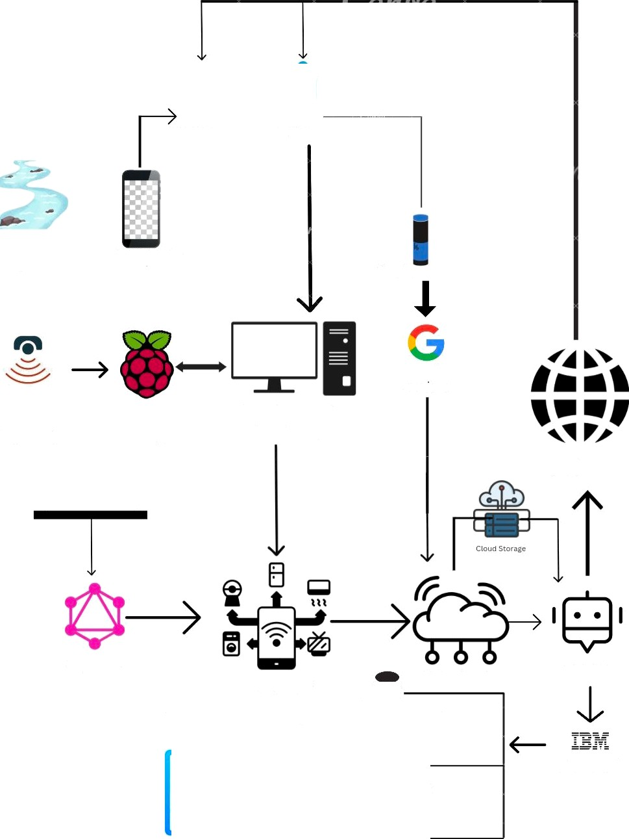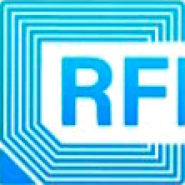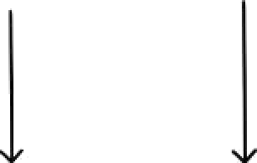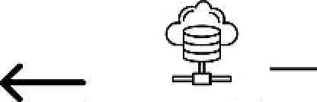

i

Google assistant

Wireless Sensor Raspberry pi Raspberry pi Networks Board Desktop

Zigbee

IOT device

email,notifications etc

Google services

IOT cloud service

REM AIN D ER STO RAG E

Web UI

IBM BOT

Cloud watch logs

KEY security management audio record

BOT interaction